Great Easton C of E VA Primary School

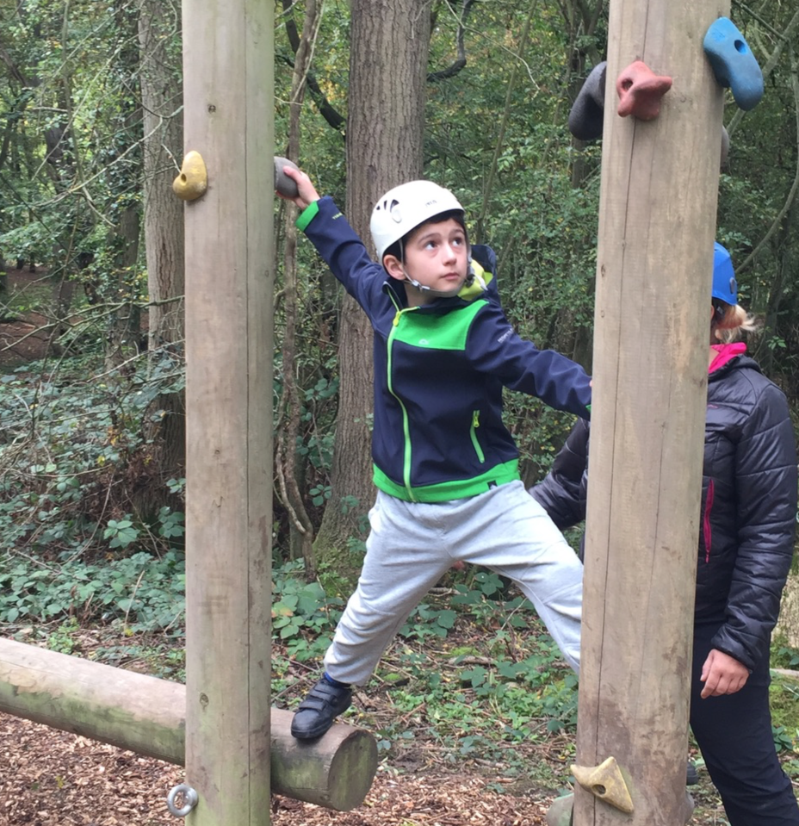

Charging and Remissions Policy 2019-2020

This policy has been equality impact assessed and we believe that it is in line with the Equality Act 2010 as it is fair, it does not prioritise or disadvantage any pupil and it helps to promote equality at this school.

All staff consulted: January 2020
Agreed by Governors: 20th January 2020
This policy is to be updated as necessary but will be reviewed at least annually.

The school sometimes involves the children in extra-curricular activities such as day trips, visits or presentations by visiting performers. Although schools cannot charge for school time activities, it is hoped that parents and other will make a voluntary contribution and thereby support the activity.

All requests to parents for voluntary contributions make it clear that they are voluntary. Children of parents that do not contribute will not be treated any differently. No pupil will be left out of an activity because his or her parents cannot or will not make a contribution of any kind.

If a particular activity cannot take place without voluntary contributions from parents, the situation is explained at the planning stage. Voluntary contributions will not exceed the actual cost of the trip or event.

Where there are not enough voluntary contributions to make the activity possible, and there is not a way to make up the shortfall, then it will be cancelled and contributions reimbursed.

Musical Instrument Tuition

Individual music lessons are available if requested by parents. These are provided by peripatetic teachers from Essex Music Service. There is a charge which includes the cost of tuition only. Parents are responsible for providing sheet music and hire or purchase of musical instrument and necessary insurance. We expect to receive payment before the term begins. If you are entitled to free school meals a voucher of up to £40.00 against the cost can be obtained from Essex Music Service.

Swimming

The school is obliged to provide swimming lessons in accordance with the national curriculum but we do request a voluntary contribution towards the cost of the hire of the pool, instructor and transport to the pool. This is currently £10 for 10 lessons. The key stage two classes all swim for one term each - any children finding swimming challenging are encouraged to swim for the next term until they are more confident swimmers.

School Dinners

School meals are cooked on the premises and are available at a daily cost of £2.20 for Key Stage Two children, which can be paid in advance either weekly or half-termly. All Reception, Year 1 and Year 2 children are entitled to a free school lunch (hot or cold).

Parents are welcome to book a school lunch and come and eat with their child. Please book via the office. An Adult meal is £2.64.

Damage to School Property

Parents are asked to make a contribution towards replacing damaged or lost school property caused wilfully or neglectfully by their children or users.

