Pupil Premium Report 2017-2018

The Pupil Premium was introduced in April 2011, and is paid to the school by means of a specific grant based on the school census figures for pupils registered as eligible for free school meals (FSM) and for pupils who have been registered for free school meals at any point in the last six years (known as Ever 6 FSM). ‘Looked after children’ (LAC) also receive Pupil Premium funding. There is also a premium for children whose parents are currently serving in the armed forces. We don’t currently have any children eligible for this funding at school.
The Pupil Premium is additional to main school funding and is used by the school to help ‘close the gap’ in attainment. This is achieved by addressing any underlying inequalities between children and ensuring that funding benefits the pupils who need it most, so that there is a significant impact on their education and their lives. As a school we decide how the allocated pupil premium funding should be spent. All schools are required to report on the amount of funding received and how it is being used.

At Great Easton Primary School:
- We ensure that teaching and learning opportunities meet the needs of all pupils
- We ensure that appropriate provision is made for pupils who belong to vulnerable groups, this includes ensuring the needs of socially disadvantaged pupils are adequately assessed.
- In making provision for socially disadvantaged pupils, we recognise that not all pupils who receive pupil premium funding will be socially disadvantaged.
- We also recognise that not all pupils who are socially disadvantaged are registered or qualify for free school meals. We will allocate the pupil premium funding to support any pupil or groups of pupils in the school which have been identified as socially disadvantaged.
- Pupil premium funding will be allocated following a needs analysis which will identify priority classes, groups or individuals. Limited funding and resources may mean that not all children in receipt of pupil premium will be receiving targeted activities at any one time.

Identified Barriers:
Great Easton Primary works hard to make sure it develops a clear understanding of how socio-economic disadvantage impacts on outcomes for children. This is crucial in developing a successful Pupil Premium strategy and whole school approach.
- Cultural literacy – 9 of our pupil premium children don’t share a reading book regularly at home. They receive little adult support to complete SMART learning opportunities.

- Developing language skills and vocabulary. Linked to the area above, due to a lack of opportunities with reading, research and possibly visits and cultural experiences outside of school, many of our disadvantaged children don’t have the range of vocabulary and general knowledge that less disadvantaged children have.

- Time for teachers to monitor and evaluate teaching, feedback and assessment. Additional dedicated non-contact time for teachers to focus on the progress of all pupils, including disadvantaged pupils and share effective practice; when teachers meet with a specific focus to discuss ideas and theories as well as pupils. We developed this weekly approach in acknowledgement of the dedication of staff and the realisation that in order to improve outcomes teachers needed time.

- Lack of engagement of parents and carers in the many workshops and open lessons offered by the school that help to develop an understanding of their child’s learning and ways to support at home. Six of the children’s parents are particularly difficult to engage.

- More able disadvantaged – one of our pupils shows real aptitude for maths, however has a lot of other emotional issues which we are focusing on improving in order to ensure they can maximise their potential (they are attending horse riding). Several of the children have received mentoring, counselling and horse riding to help combat emotional and mental health difficulties and ensure they are able to have a happy and productive day at school with friends to play with and plenty of successes to celebrate. Our mentors and Solutions Sheriff are key in helping the children to feel confident and overcome other social and emotional barriers.

Desired Outcomes and Success Criteria:
Desired Outcomes | Success Criteria
1. Children to become more confident readers and SMART learners – showing an understanding of a growth mindset and the importance of practice outside of lessons. | - Children will become more fluent readers with additional practice in school. They will have daily opportunities to share a book with an adult and discuss new vocabulary and concepts.  - Assessments in reading comprehension will improve, with children working at least at their reading age, if not above.  - Children will also develop a love of reading and personal interest in books which will ensure they will gain a thirst for reading and hopefully a lifelong love of learning.  - Opportunities to complete SMART learning will be created within school time – ipads to be available for Doodlemaths, TTR, Oddizzi and reading Eggs to ensure children have the same opportunities. PPG children will be in the league tables and recognised in Friday’s Celebration assemblies (and the weekly school newsletter) for their SMART learning.
2. To develop a rich and varied vocabulary that is used in everyday speech as well as through writing. | - Training for SLT by Pie Corbett and the Talk for Writing project in Autumn term. Staff meetings for teachers and LSAs planned so that staff are confident in ways to develop and enhance children’s vocabulary, use of and understanding of language.  - Disadvantaged children will be specifically targeted to ensure they have additional opportunities and pre-teaching to enhance their language skills.  - Higher quality vocabulary will be evident in their written work and spoken English.
3. More regular assessments carried out to ensure disadvantaged children are receiving high quality teaching, support and challenge during lessons. | - Teachers are able to plan high quality activities and opportunities for disadvantaged children.  - Teachers have time to really think and discuss children’s needs during dedicated, weekly sessions every Tuesday from 2.40-3.40pm.  - Children receive high quality support, interventions, pre-teaching, challenge and opportunities due to this time to collaborate with colleagues, monitor and evaluate pupils.
4. Higher engagement from parents and carers who may be reluctant to engage with school meetings, open lessons, parents’ sessions and consultations. | - Parents and carers approached by Holly Miles or Claire Jackman and asked why they may not have been able to attend and if there was anything the school could do to make this easier in the future.  - Personal emails, phonecalls or chats to remind parents and carers before events take place in case they are not reading the Grapevine or letters home.  - Parents and carers attendance at events to be monitored and hopefully to improve.  - Feedback from parents and carers is that they feel welcome and able to approach the school. This in turn will impact on their children who may benefit from increased opportunities at home to support their learning and happiness.
5. Social and emotional well-being a priority to ensure children fulfil their potential academically and thrive at school. | - More able pupils challenged in lessons. Their potential is recognised by staff – teachers and LSAs and a ‘More Able Identification and Person Specification’ is carried out to make sure all aspects of the pupil’s talents and skills are identified.  - Mentoring and Counselling emotional support is readily available to allow pupils to thrive. Adults support children in a wide range of ways which enables their confidence and self-esteem to build and allows them to succeed in the classroom.  - The Solutions Sheriff provides additional support at breaktimes and lunchtimes and provides 1:1 and group sessions to help children develop social skills and ensures their emotional well-being. Happy children will go on to have a greater chance of success in the classroom.  - Horse-riding provides much needed calm and builds empathy amongst some of our more behaviourally challenging children. It teaches empathy and kindness. This in turn helps children to be more successful in the playground and classroom.  - For some families after school club sessions allow parents and carers respite and allow the children to engage with other children and develop their social skills.

- Planned expenditure
- Academic year |  | £22,910
The three headings below enable our school to demonstrate how they are using the Pupil Premium to improve classroom pedagogy, provide targeted support and support whole school strategies
- Quality of teaching for all
Desired outcome | Chosen action / approach |  |  |  | What is the evidence and rationale for this choice? | How will you ensure it is implemented well? |  | Staff lead | When will you review implementation?
Improved early language and vocabulary. | Use of ‘wow’ word boards in classes and magpie books. Effective modelling during shared writing and short-burst writing. |  |  |  | Research shows how quickly the gap widens between children from culturally rich backgrounds and those who have fewer opportunities. | This forms part of our SIP for T4W and will be monitored by the English Leader initially on learning walks. |  | Holly Miles | To start beginning of November and be reviewed weekly on learning environment walks, by talking to children and staff. Possibly sharing a whole school ‘wow’ word board?
Positive attitude to learning, growth mindset and high expectations for all. | Whole school focus on having a growth mindset approach and ensuring children become resilient learners – understanding what they need to do in order to further improve their learning or behaviour. |  |  |  | Some children were less motivated than others – especially certain groups of boys. Staff are working hard to develop self-confidence, stamina and grit in learning. | A whole school house team day ensured there was a consistent launch of ‘growth mindset’, assemblies and regular SIA meetings monitor children’s mindset and attitudes to learning. SLT to monitor through work scrutiny, pupil perceptions, pupil progress meetings and data. |  | Claire Jackman | Half termly at least.
Desired outcome | Chosen action / approach |  |  |  | What is the evidence and rationale for this choice? | How will you ensure it is implemented well? |  | Staff lead | When will you review implementation?
Feedback and targets have a greater impact on children’s metacognition and learning. | Staff meetings with LSAs and teachers to review the Feedback policy, compare how teachers are giving feedback to ensure consistency and to develop a system of targets which are meaningful and will impact upon children’s learning. Children are actively taught about becoming better learners and understanding how they learn. They are encouraged to give meaningful feedback about themselves and their peers. |  |  |  | Feedback is a powerful tool in engaging children with their own learning. Our system has been improved to increase pupil involvement. Children who are more engaged with their learning are shown to make greater gains. | Half termly reviews of feedback. Consultation with the School Improvement Ambassadors. Governors and SLT will monitor by talking with pupils and parents. Parents see their children’s books weekly and are invited to comment.  Regular book scrutinies to monitor the impact of feedback and targets on children’s work. |  | Claire J | At the end of each half term.
Total budgeted cost |  |  |  |  |  |  |  |  | £5160
- Targeted support
Desired outcome | Chosen action / approach |  | What is the evidence and rationale for this choice? |  |  |  | How will you ensure it is implemented well? | Staff lead | When will you review implementation?
Increased maths, reading and writing achievement. | Individual and small group teaching on specific areas. |  | Closing the gap by using a teacher to provide high quality teaching in specific areas of reading, writing or maths (as identified by class teacher). |  |  |  | By monitoring the teacher, speaking with targeted pupils and tracking progress and results in everyday work and assessments. | Anne-Marie Woodmore. | Half termly as part of pupil progress meetings.
High quality, well-matched interventions and opportunities for children – especially in phonics, reading and writing. | Use of a highly skilled LSA to deliver a number of high quality programmes that enable children to focus on key skills of reading and writing. |  | Children who don’t get additional support at home, read with an adult or practise phonics or handwriting have additional opportunities with Helen Williams at several points during the week to narrow the gap between them and their peers. |  |  |  | SendCo monitors Helen’s training and teachers meet with both to review provision offered. Headteacher meets with SendCo weekly. | Helen Williams (LSA) and Kathryn Mayle (SendCo) | Reviewed at least half termly.
EPS Maths Intervention  (EPS MI)  The EPS MI is a 12 week programme which will increase pupils’ arithmetical skills. On average pupils make double the rate of progress on standardised assessments when compared to the progress made by pupils not using the intervention. | The programme is  designed to be delivered on a daily basis, 20 minutes a day for at least 12 weeks.  • Needs to be delivered consistently by a trained adult on a daily basis. |  | EPS MI is a programme of number based learning sessions designed to boost and secure the basic number skills expected in key stage 1. The content and delivery of the programme has been developed from evidence-based psychological research. The programme has successfully been used with pupils from Key Stage 1 to Key Stage 4. |  |  |  | A senior member of staff must be identified to provide support to the delivering LSA – our SendCo Kathryn Mayle is responsible for monitoring. In addition the Educational Psychologist also comes to check the intervention programme is running well. | Kathryn Mayle (SendCo) | Reviewed weekly.
Total budgeted cost |  |  |  |  |  |  |  |  | £3530
- Other approaches
Desired outcome | Chosen action / approach |  |  | What is the evidence and rationale for this choice? |  |  | How will you ensure it is implemented well? | Staff lead | When will you review implementation?
For some families after school club sessions allow parents and carers respite and allow the children to engage with other children and develop their social skills. | Before and after-school club places made available for children to attend. |  |  | To help develop children’s confidence and social skills and to help them feel a sense of belonging. In addition, to give foster parents some respite. |  |  | Reviews with foster parents and members of staff or club organisers.  Foster parents to feedback. | Sophie Delaney and Stacey Lawrence. | Every week initially and fortnightly thereafter.
Social and emotional well-being a priority to ensure children fulfil their potential academically and thrive at school. | Mentoring and Counselling emotional support is readily available to allow pupils to thrive. The Solutions Sheriff provides additional support at breaktimes and lunchtimes and provides 1:1 and group sessions being. |  |  | Adults support children in a wide range of ways which enables their confidence and self-esteem to build and allows them to succeed in the classroom.  This area is particularly important for a more able disadvantaged child. |  |  | Marie Rolph from Three Oaks Counselling has review meetings with mentors to review their practice.  Claire J and Kathryn Mayle maintain an overview of mentoring and the work of the Solutions Sheriff and its impact on pupils. | Liz Page, Helen Williams, Sally Cranfield | Half termly trhough discussions with mentors, Solutions Sheriff and with teachers during Pupil Progress meetings to ensure impact is seen in the classroom as well as the playground.
Increased empathy, happiness and kindness for children who are particularly stressed, anxious or find understanding others a challenge. | Two-three places are available at the Riding for the Disabled centre and the children go for a riding lesson once a week. |  |  | Horse-riding provides much needed calm and builds empathy amongst some of our more behaviourally challenging children. It teaches empathy and kindness. This in turn helps children to be more successful in the playground and classroom. |  |  | Claire J and governors attend horse riding periodically to see how the children are progressing.  Monitoring the behaviour incidents provides an indication of the success of horse riding. | Sally Cranfield | Claire J to review termly with Sally Cranfield and report to governors.
Total budgeted cost |  |  |  |  |  |  |  |  | £14,440

Current Attainment (Autumn Term – second half (this term’s data hasn’t been added yet)
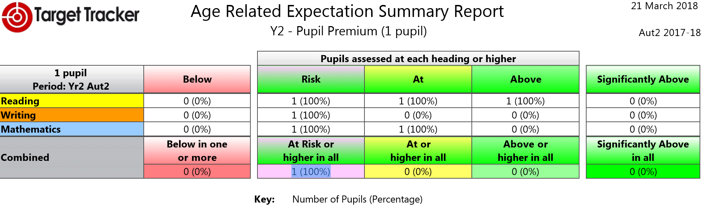
Writing is an issue here with this child working ‘at risk’, they are at in maths and above in reading.

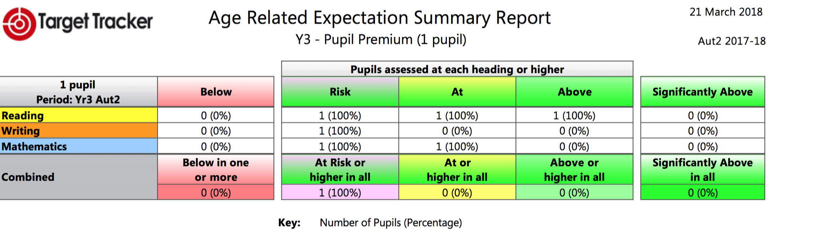
Writing is also the issue here with reading ‘above’ and maths ‘at’.
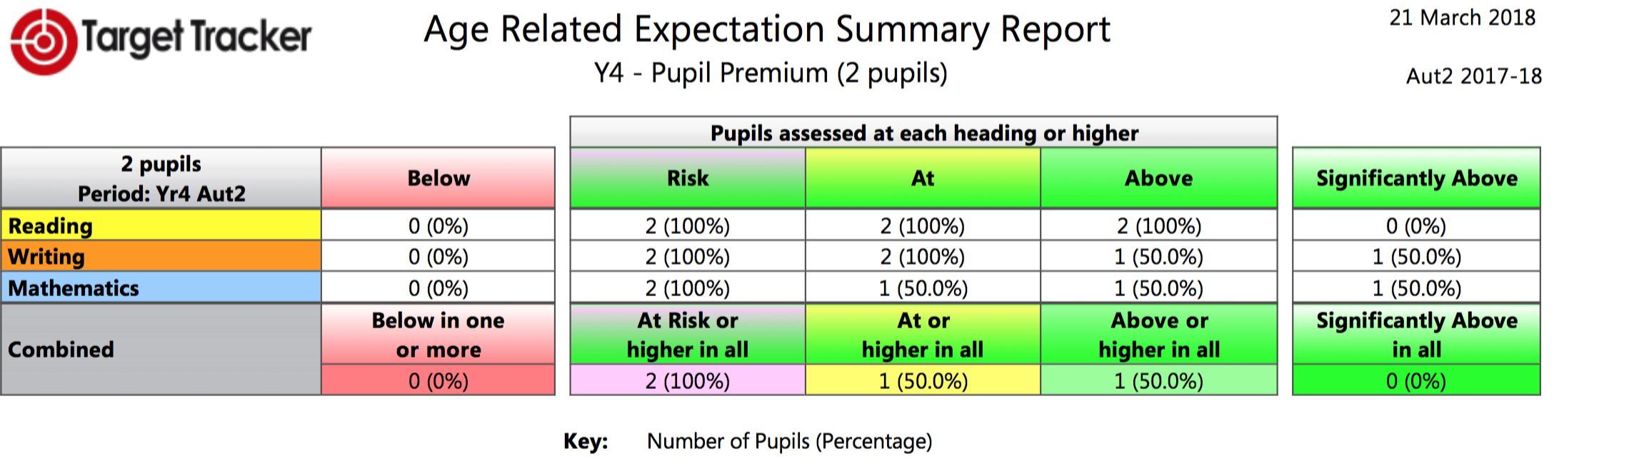
Both children are above for reading, 1 child is at and one above in writing and the same for maths.
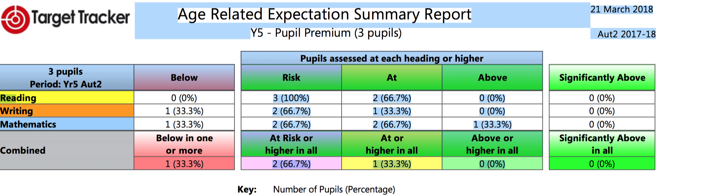
1 of the pupils is at risk for reading and below in writing and maths (he is on the SEND register) and another pupil is at risk for writing but at for reading and maths and the third child is at for reading and writing and above for maths.

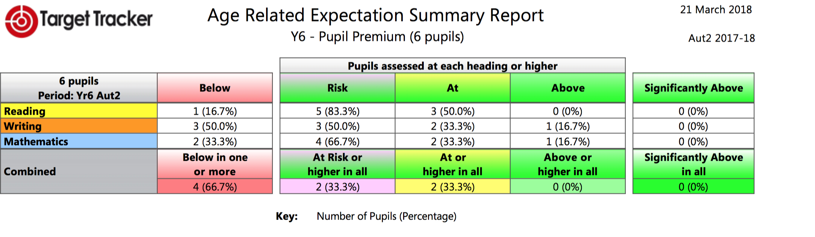
One child is below in reading, 2 are at risk and 3 are at. 3 are below in writing, 2 are at and 1 is above. In maths 2 are below1 is at risk, 2 are at and 1 is above.

